

TDS 3651

Visual Information Processing

Trimester 1 Session 2019/2020

Assignment 1

Lecture Section: TC01

Tutorial Section: TT01

Made by: Wayile Jialade 1151102347

# Abstract

This assignment is for students of TDS 3651 – Visual Information Processing under Ms. Wong Lai Kuan. The students are required to apply different image manipulation techniques learnt in the past tutorial and lectures in order to process the given input satellite image and make further enhancement to them.

# Introduction

The purpose of the assignment is to design an algorithm that automatically enhance a set of satellite images. A set of 30 satellite images, along with the corresponding enhanced image, is provided for us to design the enhancement algorithm. An example of an input satellite image and an enhanced imaged is shown below:



Input Image Enhanced Image

# Description of Methods

There are three methods of image processing techniques I used here:

1. Gamma correction with Power Law Transform: Since the color intensity increases according to the sample output, it means that we need to decrease the gamma value in order to reinforce the appearance of the color.
2. Color Histogram Equalization: Equalize the image splitting the image after HSV conversion and applying cv2.equalizeHist() to the V channel, merging the channels and convert back to the BGR color space.
3. Apply Gaussian Blur to remove some noise after the Color Histogram Equalization

# Results & Analysis

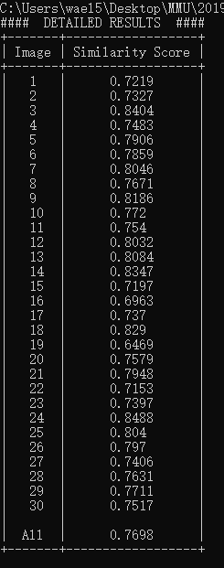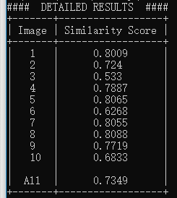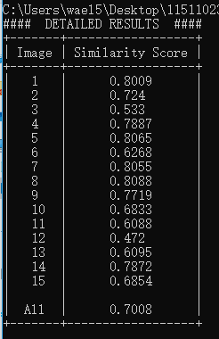

(Final Result & Analysis for set1, set2(first 10 images) &set2(15 images) respectively)

The accuracy will only be about 57% in set 1 if do not apply Gaussian blur as there are many noise pixels formed after the color histogram equalization.

I will pick two images which are best & worst in terms of the similarity results below:

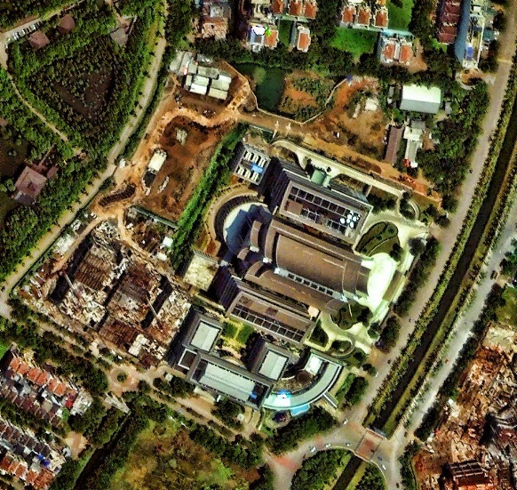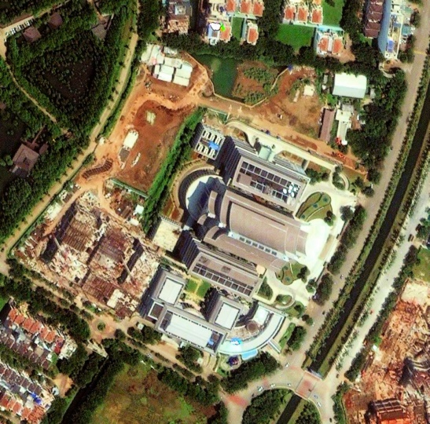

Best Result (0.8453) -> (Left: Ground Truth, Right: Output)

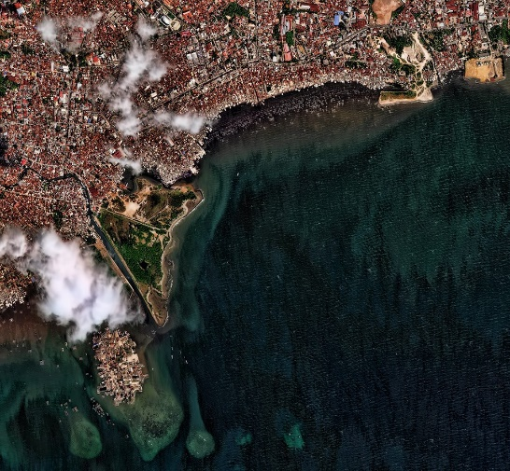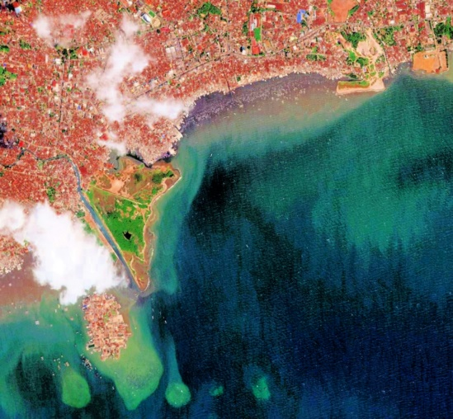

Worst Result (0.6469) -> (Left: Ground Truth, Right: Output)

From the results, we can observe that the more color variety of an image has, the better the similarity result we will get & vice-versa.

# Suggestions for Improvement

* Light Intensity value still a bit high which caused loss of details for the output image as compared to the ground truth image given
* Color reinforcement might be still too strong as compared to the ground truth image given.